Te Kaunihera Whakawhanaunga o nga Minita Hohopera, Hauora

INTERCHURCH COUNCIL
FOR HOSPITAL CHAPLAINCY
ANNUAL
REPORT
2019

CONTENTS
4
Chairperson’s Report

6
Chief Executive Officer’s Report at 30 June 2019

8
The Year in Review

10
Profiles

17
Revenue & Expenditure

19
2020 Initiatives

21
Financial Statements

CHAIRPERSON’S REPORT
It has been a privilege to serve ICHC over the past year; after one year as an Independent Trustee, I was elected as Chairman on 30th November, 2016. At the end of the 2019 calendar year I will have completed 4 years as an ICHC trustee.
National Office Tim Pratt, appointed as National Manager in June 2017 (title changed to Chief Executive in mid 2018) resigned in June 2019. Anna Northcott formerly Strategic Partnerships Manager, also resigned her role as National Operations Manager in June 2019. We are grateful for both Tim and Anna’s service and wish them well with their future respective endeavours. While an unsettling and difficult time for the organization, we are thankful for the efforts of Board members, Regional Chaplains and Wellington staff who worked hard behind the scenes to ensure continuity of operations. Judy Lyons also resigned during the year, and Keith Ardern relocated to Tauranga, while continuing to manage the overall accounting function, albeit on a part time basis. Cindy and Brydie continue in their existing roles and we greatly appreciate their dedication and commitment.
Simon Greening who has been assisting the Board with HR matters, was confirmed as Interim Chief Executive (part time) in July. He is a very skilled operator, passionate about chaplaincy and has a good working understanding of our operating environment. He is a partner in Auckland Law firm, Gaze Burt. Thank you, Simon for hearing God’s call and taking up this position. Simon intends to work closely with the Regional Chaplains; Barbara Walker, Sandra Wright-Taylor, Julian Perkins and Tony Lenton, the Senior Catholic Hospital Chaplain. Peter Brown resigned during the year, and I do wish to thank him personally for his time with us both as a Trustee and latterly as a Regional Chaplain.
Governance The role of the Board is to exercise governance and stewardship across the organization, to engage in and set the strategy, to ensure statutory and regulatory compliance, to monitor risk management initiatives and to provide for appropriate resourcing to meet agreed strategic objectives. With the addition of the Wesleyan Methodist Church, we now have representation from ten denominations; when Additional Trustees are included it becomes a large Board. Consequently we engage with our stakeholders to ensure the Board is manageable and that we achieve diversity in its widest sense and
importantly in terms of skills and governance experience.
Most Board members serve on either the Audit and Risk, or the People and Culture Committee. During the year we established the Spiritual Diversity Committee in response to the perceived need to engage with other faiths in regard to Hospital Chaplaincy. While we continue to research this issue, we have deferred any substantive initiatives relating to spiritual diversity until 2020.
Catherine Fyfe, Bevan Killick, Rev Lucy Nguyen and Rev Tale Hakeagaiki all resigned as trustees during the year, and we record our grateful thanks for their service. Three new members were appointed; Anne Dickinson as a Catholic representative, Bishop Richard Wallace as an Anglican representative and Barry Fisk as a representative of the Wesleyan Methodist Church. We warmly welcome each of them to the Board.
During the year the Board met physically four times and once by skype.
Mission and Purpose Our commitment is to providing healthcare Chaplaincy across all DHBs in New Zealand from a Christian foundation. We seek to promote good health outcomes through pastoral care and the sharing of God’s love, while being sensitive to the needs of all patients, families and staff. Our chaplains work alongside other health care professionals and in many cases are seen as valued members of inter-disciplinary teams. Spiritual care and support is provided in the context of love and respect for the patient/client regardless of their faith, denomination or religious/spiritual beliefs. Chaplains will often coordinate access to an alternative spiritual care resources, when requested. We are committed to the principles of the Treaty of Waitangi and to our own Code of Practice. Chaplains and Volunteer Chaplain Assistants (VCA’s) are required to be held in good standing with their own church.
The necessary process of amalgamation has progressed during the year, although two regions are yet to formally accept this proposition. A set of standardized employment policies and processes have been developed, designed to improve both efficiency and effectiveness of chaplaincy services within every public hospital. Terms of Reference for Local Support Committees (LCC’s) have been revised and refreshed and MoU’s developed and agreed with DHB’s. While much has been achieved, the Board became very concerned during the latter part of 2018 around the apparent opposition, frustration and antagonism from both chaplains and other important stakeholders including churches and DHB’s. This is unacceptable in a Christian organisation, contrary to our stated values and unsafe for all of our staff. Consequently management was counselled to soften and if necessary slow the pace of change and take a more flexible, conciliatory and consultative approach. How we conduct ourselves as we go about the business of our mission is critical, and in the end we will be measured on how well we live out our values.
Catholic and ICHC Relationship Principles A refreshed Principles document was negotiated and agreed between the six Catholic Bishops and ICHC, affirming that all Hospital Chaplains are ICHC chaplains and are expected to work in harmony as one integrated ICHC Chaplaincy team and that all member churches have agreed to work together in an ecumenical partnership. ICHC will continue to bulk fund Catholic Chaplains while recognising that the ecclesiology of the Catholic Church requires that its bishops employ Catholic hospital chaplains. The Senior Catholic Chaplain is considered part of the ICHC Senior Leadership Team.
DHB’s A good relationship with each DHB is paramount, and we need to invest more time to building value and connection with them. Rather than seeking to take over chaplaincy, the overwhelming evidence is that they are supportive of our work and our current church based model. In future we need to consult with DHB’s about issues which affect them before a decision is made; finding solutions which are workable for both parties is critical and this process will be enhanced by the proposed Tri-Partite agreement involving MoH, DHB’s and ICHC.
Ministry of Health Only in the later part of the financial year were we able to constructively engage with the Ministry as regards the renewal of the contract. When we did, we found them extremely supportive of our work, understanding of various internal pressures we were facing, and prepared to not only renew the contract but to invest further into ICHC with new funds for Mental Health Chaplaincy. Current methods of reporting, especially through our current emphasis on statistics are falling short of the desired Results Based Accountability (RBA) model that Government is seeking to transition all social service providers towards. Our management have worked to establish a new set of reporting standards that more adequately measure the patient experience and we await MoH sign off on these, in due course.
Local Support Committees In a number of regions LCC’s are operating extremely effectively; sadly in a few areas they are defunct. We need to invest time and resource in the future such that LCC’s are reinvigorated, repopulated and reconnected to their church and communities. In today’s healthcare environment, Chaplains work in communities, as well as hospitals. We see LCC’s as critical to our success in the long term, securing local funding, providing pastoral support to Chaplains, recruiting volunteers, assisting with Locum cover and promoting the importance of Chaplaincy. In short we need work closely with them, give them the respect they deserve and provide them with meaningful information such as quarterly reports of income and expenditure, which will enhance transparency and understanding. ICHC is an arm of the church and LCC’s are an extension of that arm.
Financial Position We can again report (for a second year running), that ICHC’s finances are in good order. It remains important that we demonstrate to our stakeholders good stewardship. Fundraising will always be key to increasing capacity and service levels, and functioning and effective LCC’s can make a valued contribution to revenue generation. But while we continue to seek additional financial support, we need to be thankful for what we have and grateful to those who contribute.
Conclusion Finally, thank you to Chaplains, paid and voluntary, members of LCC’s including administrators, the Senior Leadership Team including the Senior Catholic Chaplain and our Wellington based staff, ICHC Trustees who take responsibility for the governance of our organisation, DHB staff who care about and support our work, the Ministry of Health and other funding partners who recognise and value the mission and the Christian churches of New Zealand, our primary stakeholders. Let me also thank those who pray quietly behind the scenes – be assured that you do make a difference.
Chris Bryan Chairman, September 2019

CHIEF EXECUTIVE OFFICER’S REPORT
Serving people was an essential part of Christ’s ministry. Jesus loved and served people regardless of their creed, beliefs, ethnicity, status, or class.
His posture was service to others. This was magnificently demonstrated in John 13, which records Jesus washing the feet of his disciples. After supper Jesus left the table, got down on his knees and washed the feet of disciples. Jesus then makes this remark to his disciples:
“I have given you an example to follow. Do as I have done to you.”
Inspired by Christ’s example of humble service, we have the privilege of serving patients, their whanau, and extended networks, by demonstrating compassion through listening and providing spiritual care and support. Our mandate is to serve people regardless of creed, beliefs, ethnicity, status, or class. We are genuinely grateful and appreciative of the work of our chaplains and VCAs. We also want to take this opportunity to express our appreciation to our stakeholders.
We look forward with anticipation to 2020. We have a number of new partnerships and initiatives that we will be focusing on next year which are outlined in this Report.
Thank you for your continued support.
Blessings
Simon Greening Chief Executive Officer

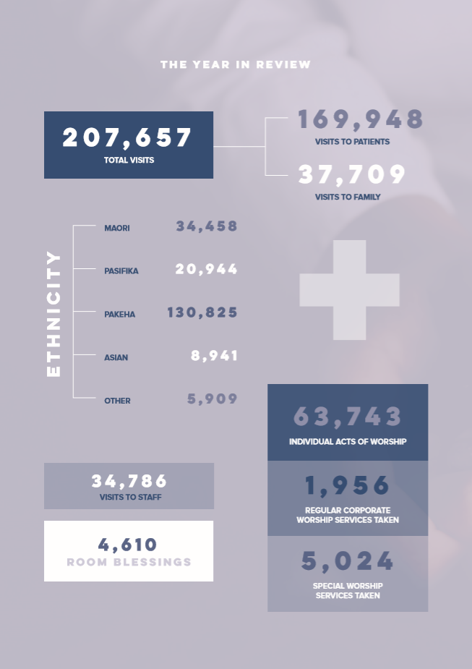
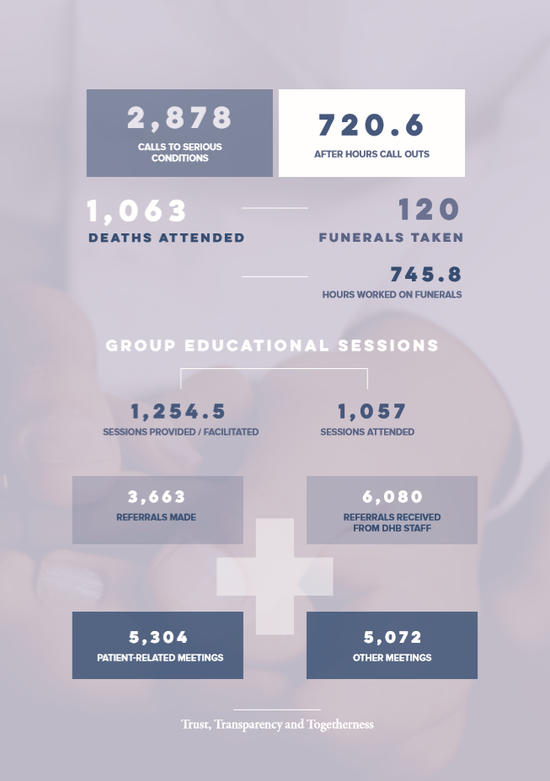

PROFILE
JOSEPH (JOE) GRAY CENTRAL REGIONAL MANAGER
Born south of the mountain and raised in the northern region of the province, Taranaki or more especially the Maunga in its center has been a major influence in who I am. I am a provincial person with a heart for people, their welfare and wellbeing, who especially understands people of the land. People who often feel they are the “underdog”, forgotten, misunderstood and misrepresented. Trade training through a Plumbing & Gasfitting apprenticeship added trouble shooting, prioritising and work ethics that laid a foundation that have continued through to today. I regularly reflect that I’m a “hands on” type of guy being a practitioner rather than an academic. Over 60+ years of preparation, half of which includes pastoral work, I believe Hospital Chaplaincy has me to be the right person in the right place at the right time.
I enjoy the place of supporting our people and community through the skills that have been developed in me. For people of every culture, faith and gender, Hospital Chaplaincy gives me the privilege to walk with people in their vulnerable spaces supporting them where they are. Yes that does involve the application of the spiritual ordinances of denominational faith, which are rich and rewarding. But most regularly it involves connecting spiritually with patients and families who aren’t necessarily looking to or even expecting religion to meet their needs. I also enjoy participating alongside teams who share similar perspectives. For me this includes supporting Clinical staff and Managers in our DHB’s 2 District hospitals, leading and training our teams of Chaplaincy Volunteers and now pastorally overseeing Chaplains in the Central Region. To use author, Rick Warren’s words, “We are better together”.

PROFILE
REV BARBARA WALKER QSO. ICHC HOSPITAL CHAPLAIN REGIONAL MANAGER FOR MIDLANDS AND MID CENTRAL DHB HOSPITAL
I was called by God into hospital chaplaincy over 15 years ago. I came into this very special ministry after working for many years as a nurse midwife not only in New Zealand but also in some of the most challenging situations around the world in war zones, huge refugee camps and remote mission hospitals in Africa and Pakistan.
After returning to New Zealand from Mozambique in 1996 following a death threat, I struggled to continue working as a nurse in the New Zealand. I wanted to stay in the hospital environment and began to look at various options.
I began looking at the the possibility of becoming a hospital chaplain. After much prayer and guidance from some trusted friends, things slowly came together. A conversation with an Anglican Bishop on a road trip to Te Anau resulted in my looking seriously at ordination as part of my hospital chaplaincy journey. The journey towards ordination began and finally after some time of study, reflections and training I was ordained as an Anglican Priest in 2004 and then 5 years later I was appointed to the position of full time chaplain at Hawke’s Bay Regional Hospital in February 2009.
I am passionate about hospital chaplaincy. For me it has been, and still is, God’s thread in His tapestry of my life. Over the years I have been involved in this coalface ministry, God has used my nursing and midwife background, my cross cultural experiences and my interfaith experiences in ways and situations which have blown me away, not just once but many many different times. It is a real privilege, and hugely humbling to be with a family as their loved family member passes away, or to journey with a critically injured young person who was being supported by his family whom I first met in the intensive care unit where they asked me to pray for their son. The prayers continued week after week, month after month, as the journey continued through the valleys, up on the mountain tops then down in the valleys, often valleys of despair. The prayers continued as this young man’s condition improved and he was transferred to another ward and then to the rehabilitation ward, with
good days and tough days. Finally, after months, the day arrived for him to leave hospital and the smiles, the hugs, the joy, the tears and then to hear this young man say, “God has something special for me to do and I am going to continue my journey with Him.” was very moving and something that I will never forget. Sometime time later I met this young man’s mother, I asked after her son and she said, “He is doing well and wants to become a pastor.”
Another part of this ministry that I really enjoy is listening to staff and encouraging them, my nursing and midwifery background being a huge advantage, especially as, having walked in the both the nursing and midwifery world. I have a natural bond with them. In my present role I have many opportunities to encourage the new graduate nurses as they begin their nursing careers in the hospital. What a privilege to share with them and encourage them to journey with their patients, not only seeking to address a patient’s physical, psychological and mental concerns but also asking about the patient’s spiritual needs and if needed referring that patient to the hospital chaplains.
In my new Regional Manager’s role, I have a wonderful opportunity to support new chaplains as they being their ministries. I am also hoping that we can attract younger people to seriously pray and inquire about becoming a hospital chaplain. We need to support and guide this next generation of Hospital Chaplains who will be there in the coming years to support all people who suddenly find themselves entering our hospitals, perhaps as a patient, a family member or as a staff member.
Why am I a hospital chaplain? First and foremost, it is a ministry God has called me into and secondly I love the challenges, the joys, the amazing people I meet. Sure, at times it is tough, at times I wonder if I can keep going, but at times like that, I Thessalonians verse 24 comes to mind: “He who calls you is faithful, He will do it.” This verse has meant a lot to me, not only now in my hospital chaplaincy ministry but also when I was working in very challenging situations around the world.
Every day is different, every day is special, every day is a gift. that is why I continue to be a hospital chaplain.

PROFILE
JULIAN PERKINS REGIONAL MANAGER, HOSPITAL CHAPLAIN
I find hospital chaplaincy amazing, working in a professional team in an environment full of people who, by default, are caring towards others. I feel honoured to walk alongside so many vulnerable people through both the challenges and joys of their healthcare journey.
It didn’t start like this: I dreaded every week of my college hospital placement doing all I could to avoid ward rounds. Thankfully, God had a parting gift for me: I was asked to drop a card off to a former student in for surgery. I found him waiting to go to theatre; despite having prayed with no one during the placement it felt completely natural to offer to pray and the timing for him was perfect, as only God can manage.
Ten years in parish transformed me: chaplaincy is now definitely the right fit for me, tapping into both my yearnings and my gifts. We are on the fringe of church and perhaps of society. We walk among the spiritual seekers, helping them to connect with what matters and to know fullness of life. Their faith journey is not mine but it is a blessing to see the divine spark in them.
I have a passion for seeing chaplaincy achieve its potential, delivering excellence in serving others through spiritual care, and I want to help shape that future. I greatly enjoy working with chaplains, just as I love hearing patients stories I love hearing your stories: you are all called and gifted and I want to help you flourish in your ministry and the work of chaplaincy to flourish in our hospitals.
Three patients stood out last Sunday. The first, a woman who seemed just to want to chat and joke, I couldn’t help thinking there are probably other patients I would be better seeing. Then she said it, ‘I’m not sure God wants to hear from me. We explored this together. She has a strong sense of God’s presence and knows in her heart that God is always with her.
The second, a man who when asked had though yes, a chaplain is just who I need to see. He works for the church as a ‘critical friend’. He wanted to explore his place on the edge of the church, his struggle with church services, and his wondering why me. Again we explored together, he observed that God might be at work in all this and that he was in the right place, on the fringe of the church, much as chaplains are.
The third, another woman who just wanted to talk was the last person I saw and greeted me with, ‘I was worried I’d missed you while I was out with my family.’ Despite having spent the day with her family she really wanted to talk. She wanted a safe space in which to explore her uncertainties and to say the things she couldn’t say to family or medics. As chaplains we hold such spaces and can assure people they are normal in their struggles and not alone.
We touch many lives in many ways; all God asks is that we turn up and are fully present, so that others may know God’s love through us.

PROFILE
SANDRA WRIGHT-TAYLOR REGIONAL MANAGER, HOSPITAL CHAPLAIN
Thirty plus years ago, I felt a deep sense of call to train as a Presbyterian minister. Although I enjoyed my first 10 years of parish ministry, there was a disconnect between parish life, the sermon preached at my ordination of the woman at the well, and what I read in the Gospels.
My first day as Chaplain at Dunedin Hospital was my ‘wow’ moment. Although I remember standing there saying “God what have you got me into?” the ‘wow’ has never gone.
For me, this is the best job in the world! Working with teams of highly trained health professionals, has pushed me to continue lifting my game through professional development and other opportunities. Being highly visible on the wards has been critical as I have never had access to patient lists. I dislike the concept of ‘cold calling’ as God’s love and presence is never cold. Each story is unique. Some stories are clothed in the faith of different spiritual journey’s, some stories are clothed in the spirituality of “Who am I? and “Who will I be?” and some are clothed in emptiness desperately looking for a glimpse of hope.
I enjoy strategic planning to look at where things are at and to re-imagine the future. It drives me to look for opportunities to ensure chaplaincy is relevant, skilled, passionate and is seen as an essential part of the Healthcare system, and integrated and valued into the life of hospital communities. I love listening to stories and in my regional role I have been inspired by stories of what some of the chaplains are doing. Creativity is part of who I am and so I am working on a sort of “Sharing Shed’ for chaplains I work with. This will be to inspire, educate, nurture, encourage share ideas and our limited resources. My dream is that this could grow!
Wow! Every day is different and every story unique.

PROFILE
TONY LENTON SENIOR CATHOLIC HOSPITAL CHAPLAIN
I cannot explain my love of hospital chaplaincy. I am moved by being in an environment that is designed to do good, to begin healing, or tries to reduce suffering, that seeks to comfort those whose last days are here whether unexpectedly or as the inevitable outcome of an incurable disease or age.
The saddest sights are to be found in the waiting rooms and the corridors of the hospitals as people wait or go home or to a consultation, to me looking so vulnerable. Yet joy is also to be found, the young parents, the person whose diagnosis reveals they are free of cancer, that the tumour is benign.
To me there is nothing more dramatic and emotional than seeing a sick person surrounded by a team of experts working to resuscitate them, using their knowledge of how our bodies work to stabilise us and even in some cases bring is back front the brink of death. There are

those too in mental health wards, who look fine on the outside but whose minds are struggling to make sense of what is happening to them and need time and care to centre themselves again.
On my rounds one morning, I visited a young woman who was sitting on her bed looking so forlorn, when I introduced myself as the chaplain, she burst into tears. She had prayed for a sign that God loved her and ‘he sent the chaplain’. Amidst the sadness there can be laughter. A dear man who looked like he had been in a fight told me he had had an eye removed surgically. Noting he was Catholic, and deeply moved by his injury, I took a risk, and said the Pope had asked me look in on him. His wife saw the joke and burst out laughing and then he did too. From his empty eye socket a small tear trickled down his cheek, the humour a brief respite from the trauma of his surgery. A Spanish woman said I prayed too slow, and asked to pray in Spanish, I have never heard such rapid speaking, this time, it was my turn to laugh.

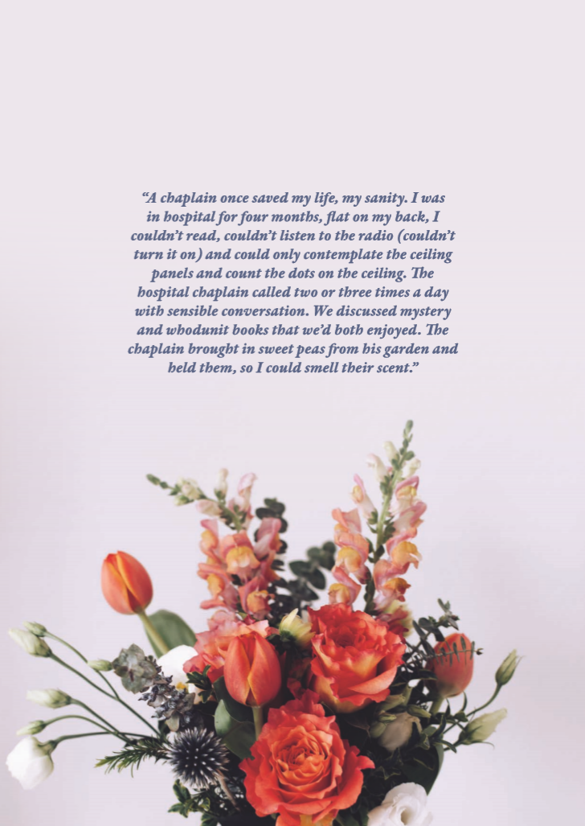

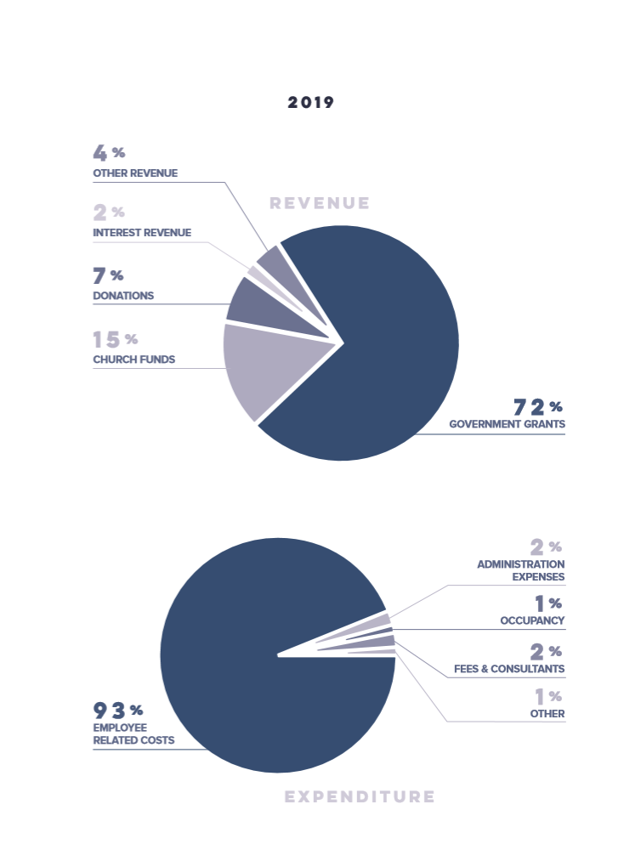

2020 INITIATIVES
We are excited about the potential of a number of new initiatives which are on the horizon for 2020.
CONTINUING PROFESSIONAL DEVELOPMENT FOR CHAPLAINS
We value the work of our chaplains and VCAs. In 2020 we will be offering Continuing Professional Development opportunities, including two Regional Workshops, and a National Conference.
We are grateful for the support we have received from the Ministry of Health, to focus on equipping our chaplains and VCAs to provide spiritual care and support for people struggling with mental health related issues.
MENTAL HEALTH FOCUS
As a result of new funding we will be appointing four new chaplains who will work in hospitals and across various Mental Health Units, with a particular focus on supporting people with mental health related issues.
BUILDING PARTNERSHIPS
We value partnerships, and in particular we are working with the New Zealand Health Care Chaplains Association to host an annual conference in partnership with NZHCA in 2020.
We look forward to strengthening our relationships with District Health Boards. To this end, we will be hosting a chaplaincy forum for DHBs in 2020, which will provide an excellent opportunity to share knowledge and ideas between the various DHBs and ICHC.
We are genuinely appreciative of the support we receive from churches and look forward to reaching out and forming new church connections in 2020.
RESULTS BASED REPORTING & PATIENT FEEDBACK
Our new RBA (Results Based Agreement) framework will provide chaplains with the opportunity to reflect on, and share narratives, as we seek to serve patients, their whanau and extended support networks.
We also look forward to receiving Patient Feedback, which will enable us to develop and improve the services we offer.

FINANCIAL STATEMENTS FOR THE YEAR ENDED 30 JUNE 2019
THE INTERCHURCH COUNCIL FOR HOSPITAL CHAPLAINCY
DIRECTORY FOR THE YEAR ENDED 30 JUNE 2019
1. CHARITIES COMMISSION– REGISTRATION
CC21346
2. SOCIETIES AND TRUST REGISTER
871553
3. DATE OF FORMATION
1 September 1997
4. TRUSTEES
Chris Bryan ..........................Chairman
Anne Dickinson ..................... Appointed
John Douglas
Catherine Fyfe .......................... Retired
Mabel Grennell ......................... Retired
Bevan Killick ............................ Retired
Heather Kennedy
Barry Fisk ........................... Appointed
Alistair McBride
Lucy Nguyen ........................... Retired
David Poultney
Pamela Tizzard
Glenton Waugh
Tale Hakeagaihi ......................... Retired
Richard Wallace ...................... Appointed

5. AUDITOR
Kendons Chartered Accountants Limited
6. BANKERS
ANZ Bank New Zealand Limited
7. SOLICITORS
Gaze Burt – Auckland

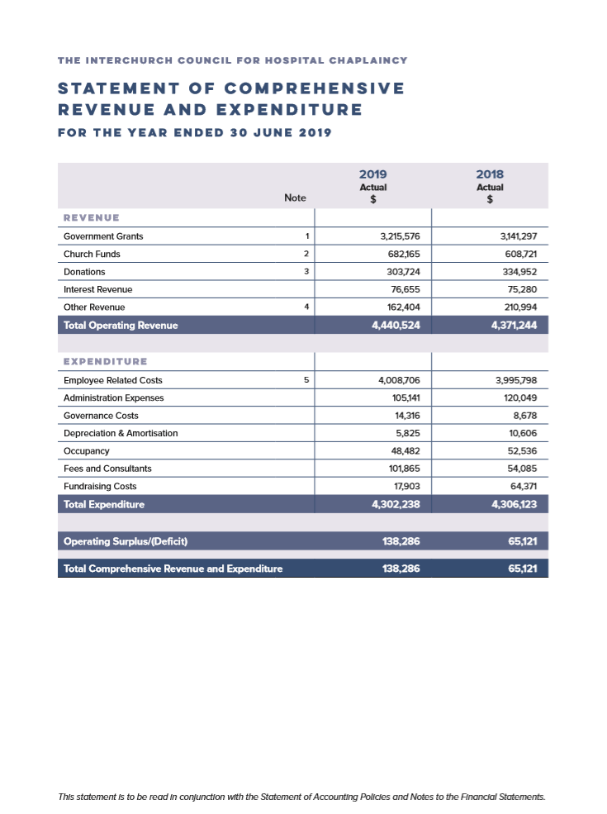
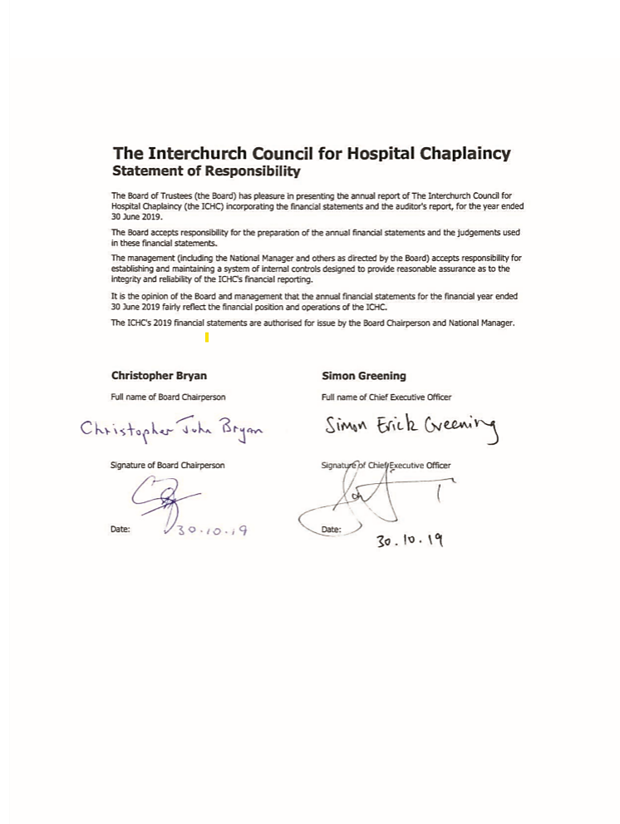

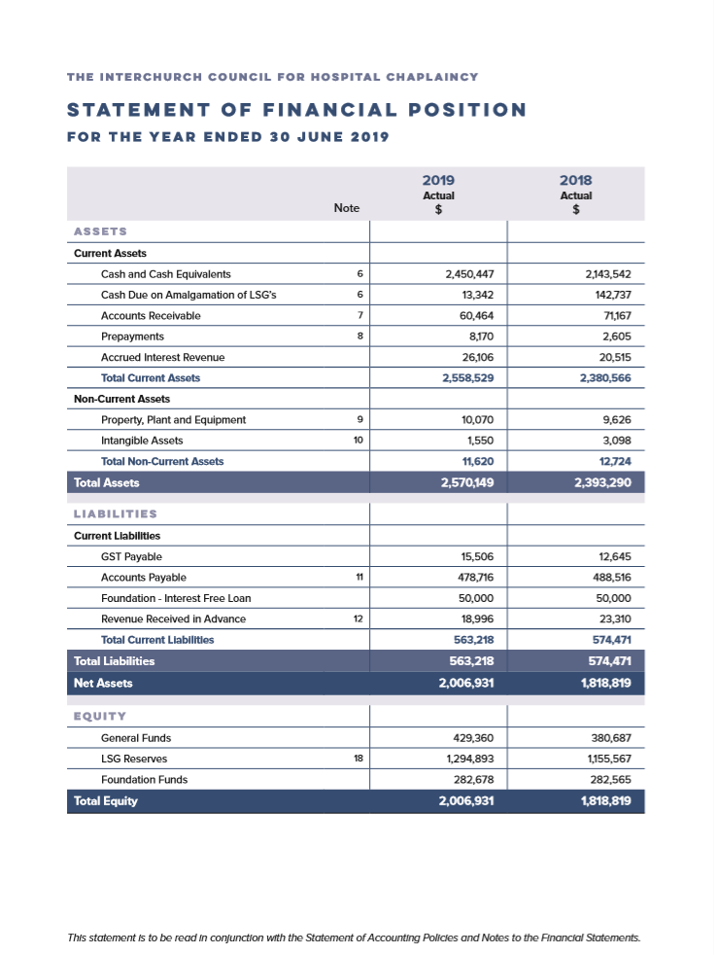
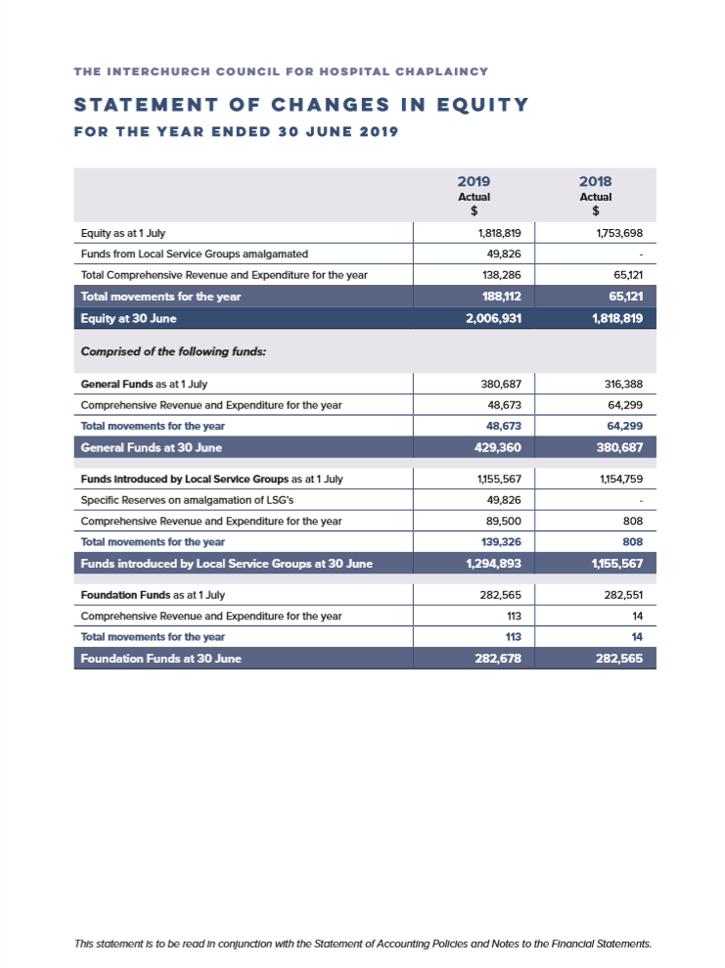

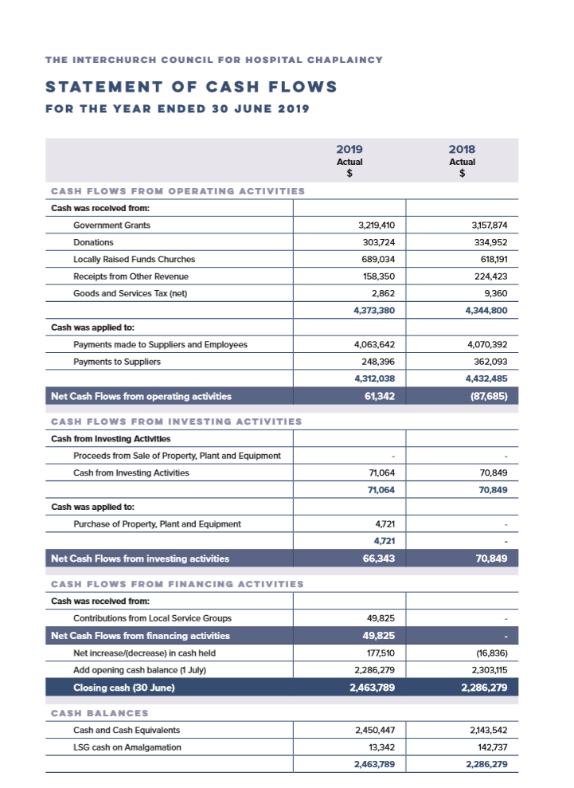
THE INTERCHURCH COUNCIL FOR HOSPITAL CHAPLAINCY
STATEMENT OF ACCOUNTING POLICIES
REPORTING ENTITY The Interchurch Council for Hospital Chaplaincy (“ICHC”) was incorporated as a Charity under the Charitable Trusts Act 1957 on 1 September 1997 and registered on the Charities Register with effect from 25 February 2008. It distributes funds to support the provision of an ecumenical hospital chaplaincy service in the public sector and other hospitals within Aotearoa New Zealand, with the support of the Ministry of Health and the Anglican Church of Aotearoa New Zealand and Polynesia; Apostolic Church Trust Board; associated Churches of Christ in New Zealand; Baptist Churches of New Zealand Ko Nga Hahi Iriri o Aotearoa; The Catholic Church in Aotearoa New Zealand Te Hahi Katorika ki Aotearoa; Methodist Church of New Zealand Te Hahi Weteriana o Aotearoa; Presbyterian Church of Aotearoa New Zealand; and The Salvation Army & Congregational Union of New Zealand.
REPORTING PERIOD
The financial statements of ICHC are for the period 1 July 2018 - 30 June 2019.
BASICS OF PREPARATION
The financial statements have been prepared on a going concern basis, and the accounting policies have been consistently applied throughout the period.
The financial statements have been prepared in accordance with generally accepted accounting practice in New Zealand, applying PBE Accounting Standards (PBE IPSAS) Reduced Disclosure Regime as appropriate to public benefit entities that qualify for Tier 2 reporting. ICHC is considered a Public Benefit Entity as it meets the criteria specified as “having a primary objective to provide goods and/or services for community or social benefit and where any equity has been provided with a view to supporting that primary objective rather than for financial return to equity holders”.
The accounting principles recognised as appropriate for the measurement and reporting of the Statement of Financial Performance and Statement of Financial Position on a historical cost basis are followed by ICHC, unless otherwise stated in the Specific Accounting Policies. The information is presented in New Zealand dollars. All values are rounded to the nearest dollar.
PBE ACCOUNTING STANDARDS REDUCED DISCLOSURE REGIME ICHC qualifies for Tier 2 as it is not publicly accountable and is not considered large as it falls below the expenditure threshold of $30 million per year. All relevant reduced disclosure concessions have been taken.
FUNCTIONAL AND PRESENTATION CURRENCY The financial statements are presented in New Zealand dollars, rounded to the nearest dollar. The functional currency of the ICHC is New Zealand dollars.
SPECIFIC ACCOUNTING POLICIES The following specific accounting policies, which materially affect the measurement of results and the financial position, have been applied:
USE OF ESTIMATES AND JUDGEMENTS The preparation of financial statements requires management to make judgements, estimates and assumptions that affect the application of accounting policies and the reported amounts of assets, liabilities, income and expenses. Actual results may differ from these estimates.
Estimates and underlying assumptions are reviewed on an on-going basis. Revisions to accounting estimates are recognised in the period in which the estimate is revised and in any future periods affected. Outcomes in the next financial period may be different to the assumptions made. It is impracticable to quantify the impact should assumptions be materially different to actual outcomes, which may result in material adjustments to the carrying amounts of investments, investment properties, plant and equipment reported in these financial statements.
Information about significant areas of estimation uncertainty and critical judgments in applying accounting policies that have the most significant effect on the amount recognised in the financial statements are described below.
REVENUE RECOGNITION Ministry of Health Funding/South Island Maori Contract ICHC receives funding from the Ministry of Health which is recorded as revenue when ICHC has the rights to the funding, which is in the year that the funding is received.
DHB Funding ICHC receives funding from the respective regional District Health Boards where Chaplaincy services are provided. This is recorded as revenue when ICHC has the rights to the funding, unless there are unfulfilled conditions attached, in which case the amount relating to the unfulfilled conditions is recognised as a liability and released to revenue as the conditions are fulfilled.
Rental Revenue ICHC receives rental revenue, for sub-let of part the Wellington National Office, which is recognised when the service has been provided.
Interest Revenue Interest Revenue earned on cash and cash equivalents is recorded as revenue in the period it is earned.
Other Revenue ICHC receives other revenue, which includes donations, gifts and bequests which are recorded as revenue when received by ICHC.
Amalgamation with Local Service Providers At 30 June 2017 ICHC amalgamated with the various Local Service Provider entities who are regionally based. The amalgamation was required because ICHC was determined to control the LSG’s under new financial reporting guidelines. The amalgamation also enables ICHC to provide an enhanced chaplaincy service nationwide, and to meet Ministry of Health funding conditions.
Cash and Cash Equivalents Cash and cash equivalents include cash on hand, bank balances, deposits held at call with banks, and other short term highly liquid investments with original maturities of three months or less, and bank overdrafts. The carrying amount of cash and cash equivalents represents fair value.
Accounts Receivable Accounts Receivable represents items that the ICHC has issued invoices for, but has not received payment for at year end. They are initially recorded at fair value and subsequently recorded at the amount the ICHC realistically expects to receive. A provision for impairment of Accounts Receivable is established where there is objective evidence the ICHC will not be able to collect all amounts due according to the original terms of the debt. This impairment loss is the difference between the carrying amount of the receivable and the present value of the amounts expected to be collected and has been included under Administration Expenses in the Statement of Comprehensive Revenue and Expenditure, if not otherwise shown separately.
Accounts Payable Accounts Payable represents liabilities for goods and services provided to the ICHC prior to the end of the financial year which are unpaid. Accounts Payable are recorded at the amount of cash required to settle those liabilities. The amounts are unsecured and are usually paid within 30 days of recognition.
Foreign Currencies Transactions in foreign currencies are recorded in New Zealand dollars by applying the exchange rates ruling at the date of the transaction. ICHC does not generally have foreign currency transactions.
Financial Instruments ICHC does not have any off-balance sheet financial instruments. Financial instruments purchased with the intention of being held for longer than one year or until maturity are recorded at cost which is adjusted for the amortisation of premiums and accretion of discounts to maturity.
Financial Assets and Liabilities ICHC financial assets comprise cash and cash equivalents and accounts receivable. All of these financial assets, except for investments that are shares, are categorised as “loans and receivables” for accounting purposes in accordance with financial reporting standards. ICHC financial liabilities comprise accounts payable and revenue received in advance. All of these financial liabilities are categorised as “financial liabilities measured at amortised cost” for accounting purposes in accordance with financial reporting standards.
Property, Plant and Equipment Property, plant and equipment is recorded at cost or, in the case of donated assets, fair value at the date of receipt, less accumulated depreciation and impairment losses. Cost, or fair value, includes those costs that relate directly to bringing the asset to the location where it will be used and making sure it is in the appropriate condition for its intended use. Property, plant and equipment acquired with individual values less than $500 are not capitalised, they are recognised as an expense in the Statement of Comprehensive Revenue and Expenditure. Gains and losses on disposals (i.e. sold or given away) are determined by comparing the proceeds received with the carrying amounts (i.e. the book value). The gain or loss arising from the disposal of an item of property, plant and equipment is recognised in the Statement of Comprehensive Revenue and Expenditure.
Depreciation Property, plant and equipment is depreciated over their useful lives on a diminishing value basis. Depreciation is reported as an expense in the Statement of Comprehensive Revenue and Expenditure.
Depreciation rates used are:
Furniture and equipment: 16 - 40% Diminishing value
Information and communication technology: 50% Diminishing value
Otago Assets 50% Diminishing value
Intangible assets Computer software acquired by the ICHC is capitalised on the basis of the costs incurred to acquire and bring to use the specific software. Costs associated with subsequent maintenance or licensing of software are recognised as an expense in the Statement of Comprehensive Revenue and Expenditure when incurred.
Computer software licences with individual values under $500 are not capitalised, they are recognised as an expense in the Statement of Comprehensive Revenue and Expenditure when incurred.
The carrying value of software is amortised on a diminishing value basis over its useful life. An amortisation rate of 50% per annum diminishing value is applied. The amortisation charge for each period and any impairment loss is recorded in the Statement of Comprehensive Revenue and Expenditure.
Impairment of property, plant, and equipment and intangible assets Property, plant, and equipment and intangible assets held at cost that have a finite useful life are reviewed for impairment whenever events or changes in circumstances indicate that the carrying amount may not be recoverable. An impairment loss is recognised for the amount by which the asset’s carrying amount exceeds its recoverable service amount. The recoverable service amount is the higher of an asset’s fair value less costs to sell and value in use.
Value in use is determined using an approach based on either a depreciated replacement cost approach, restoration cost approach, or a service units approach. The most appropriate approach used to measure value in use depends on the nature of the impairment and availability of information.
If an asset’s carrying amount exceeds its recoverable service amount, the asset is regarded as impaired and the carrying amount is written down to the recoverable amount. The total impairment loss is recognised in the Statement of Comprehensive Revenue and Expenditure. The reversal of an impairment loss is recognised in the Statement of Comprehensive Revenue and Expenditure.
Revenue Received in Advance Revenue received in advance relates to funding received where there are unfulfilled obligations for the ICHC to provide services in the future. The funding is recorded as revenue as the obligations are fulfilled and the funding is earned.
Employee Entitlements Employee benefits that are due to be settled within 12 months after the end of the period in which the employee renders the related service are measured based on accrued entitlements at current rates of pay. These include salaries and wages accrued up to balance date, annual leave earned to but not yet taken at balance date.
Income Tax ICHC is a registered charitable entity under the Charities Act 2005, and accordingly is exempt from income tax under sections CW41 and CW42 of the Income Tax Act 2007.
Goods and Services Tax (GST) The financial statements have been prepared on a GST exclusive basis, with the exception of Accounts Receivable and Accounts Payable which are stated as GST inclusive.
Services received in-kind from time to time the ICHC and in particular the regional chaplaincy services and support receives services in kind, including the time of volunteers. The ICHC has elected not to recognise services in-kind in the Statement of Comprehensive Revenue and Expenditure as the value of the service cannot be reliably measured.

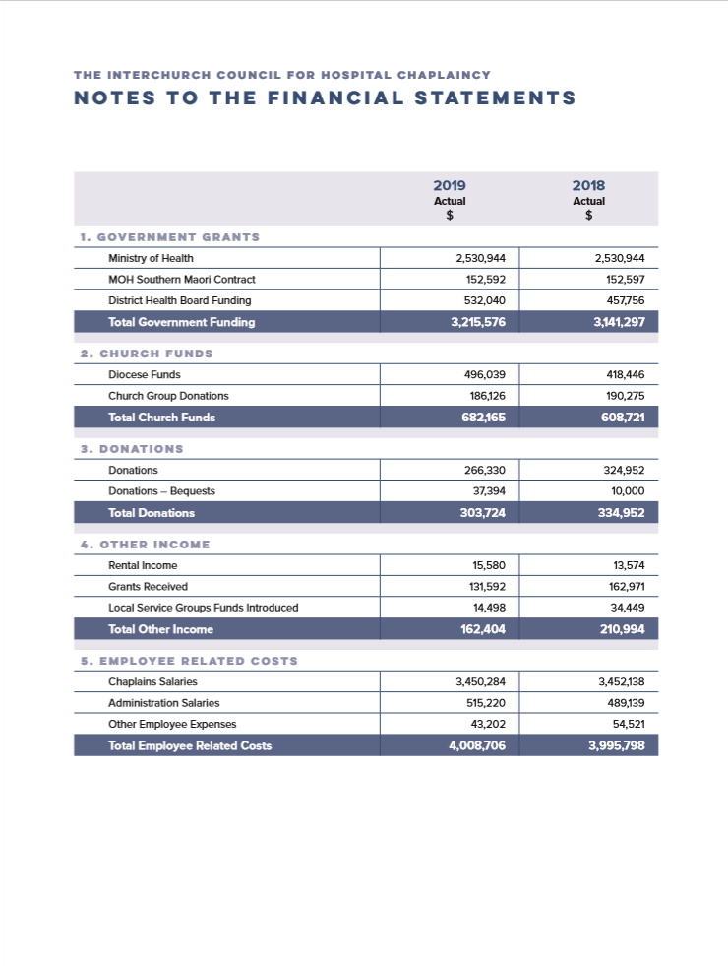

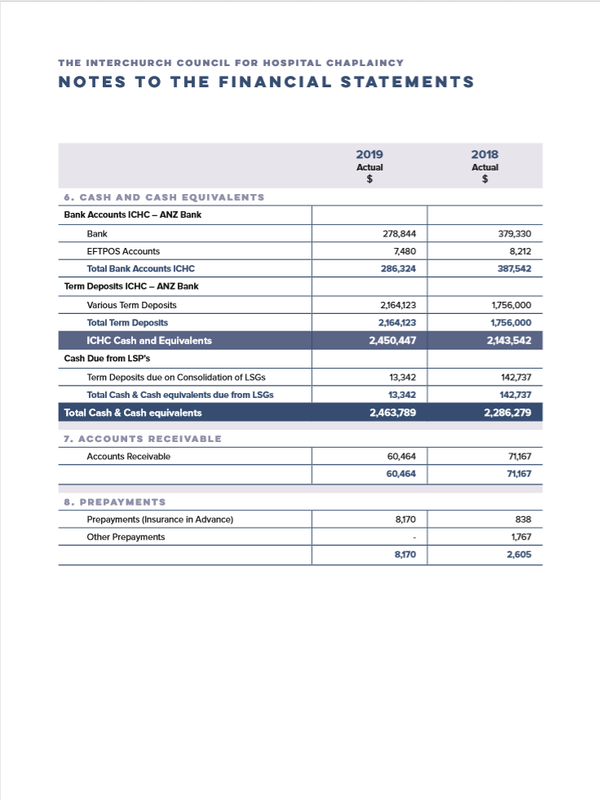

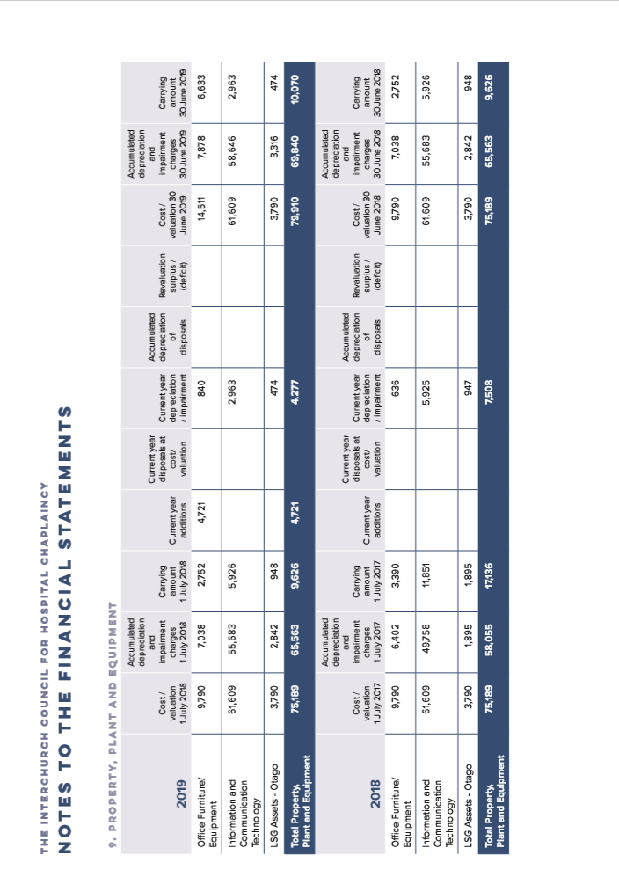
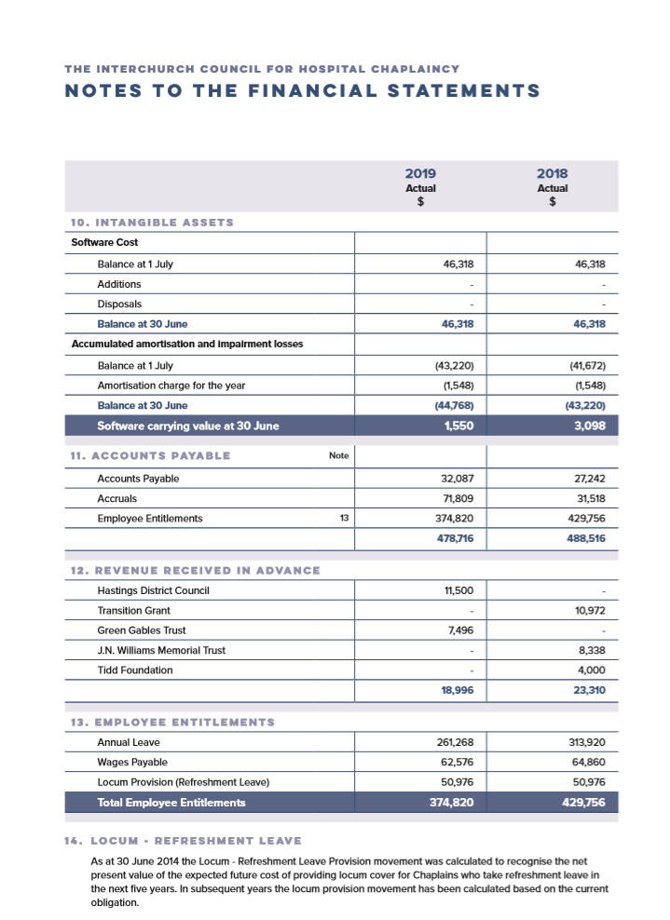
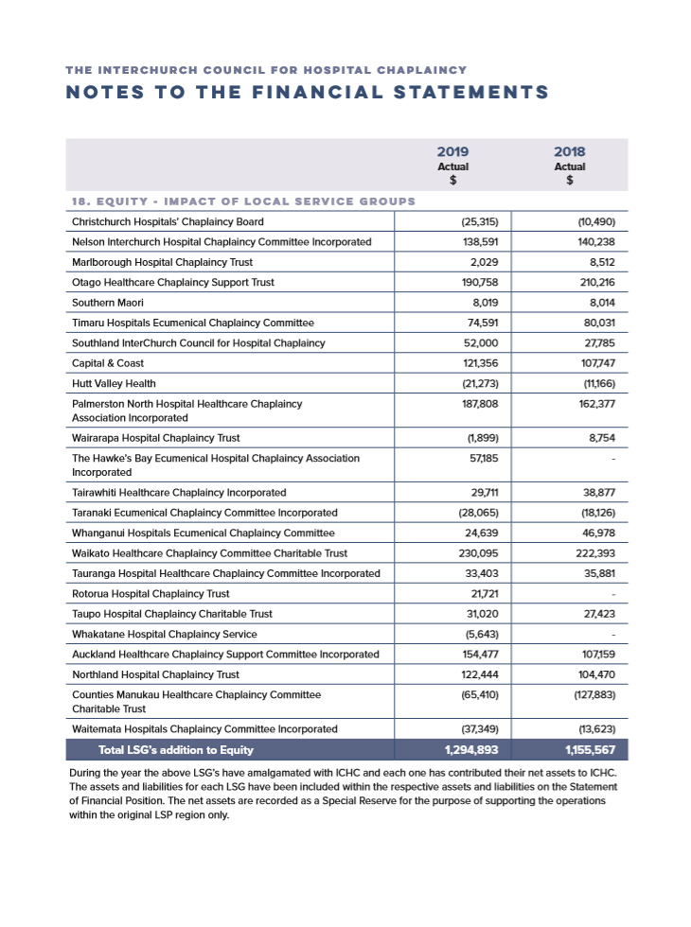
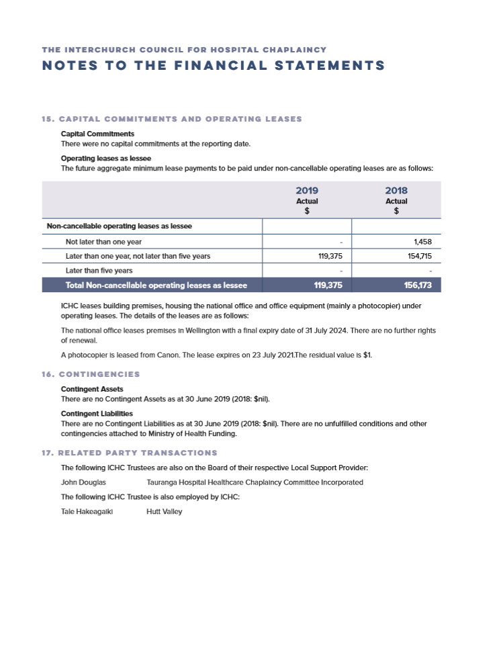

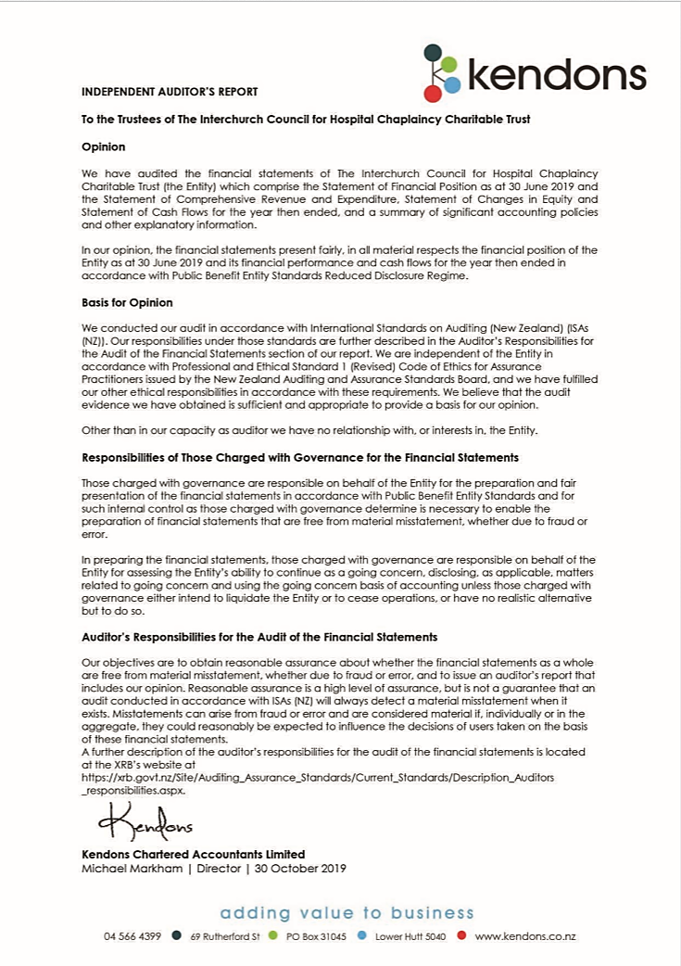
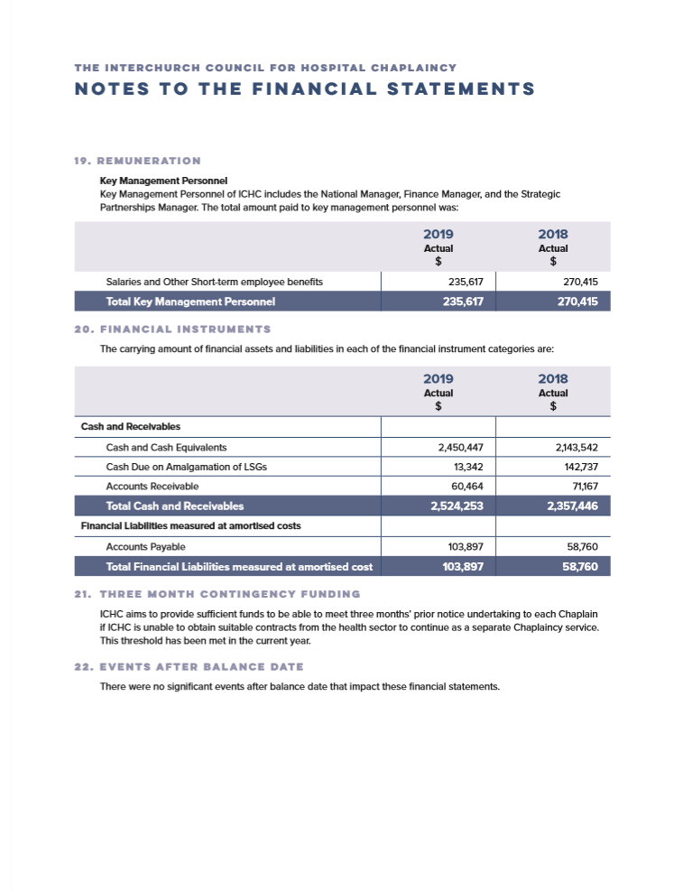

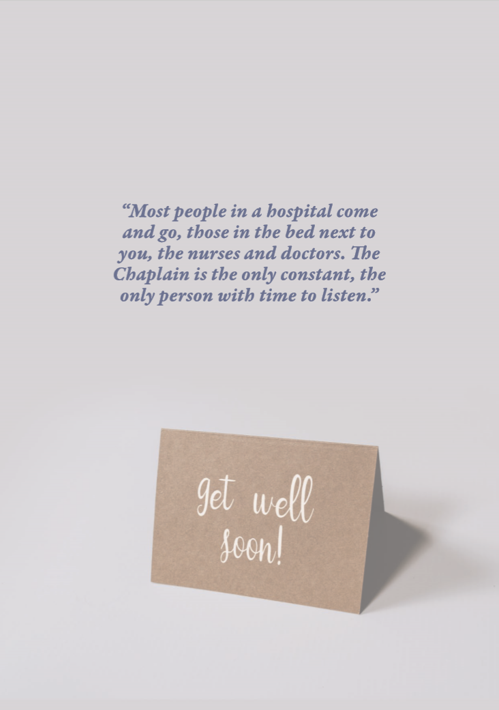

OFFICE
Sixth Floor, NZLC Building, 186 Willis Street, Wellington
PO Box 6427, Marion Square, Wellington 6141 Phone: 04 801 8008 Email: info@ichc.org.nz

WWW.ICHC.ORG.NZ

Registered Charity: CC21346

